Открытое внеклассное мероприятие

по английскому языку

«Snow White and 7 dwarfs».

Подготовила:

учитель английского языка

Зинченко Елена Николаевна

г. Серпухов

2024г.

Today we are going to perform one of the most popular German folktales “Snow White”. “Snow White” was written by the **Brothers Grimm** [Jacob](https://en.wikipedia.org/wiki/Jacob_Grimm) (1785–1863) and [Wilhelm](https://en.wikipedia.org/wiki/Wilhelm_Grimm) (1786–1859). They were [German](https://en.wikipedia.org/wiki/Germans) academics who together collected and published [folklore](https://en.wikipedia.org/wiki/Folklore). They devoted a lot of years to folk stories, myths and legends and the world of fortune-telling and mystery was definitely opened to them. The Brothers Grimm were also popular for their other well-known folktales all over the world such as “The Frog Prince”, “Cinderella”, “Hansel and Gretel”, “Little Red Riding Hood”, “Sleeping Beauty”, “Rapunzel” and others. Their stories are mysterious, unbelievable, full of wonders and recognizable all over the world. “Snow White” was published in 1812 and the whole version of the new story with all the details appeared in 1854. Almost all folktales by the Brothers Grimm were filmed by the studio “Disney” and all the cartoons had a great success and got a lor of awards in the industry of filming.

**Snow White and the Seven Dwarfs**

(After Brothers Grimm)

**Characters:**

2 Narrators

Queen

Magic Mirror

Huntsman

2 Snow White

Seven Dwarfs

Prince Henry

King

Snow White’s mother

**Narrator**:

Once upon a time in a faraway land there lived a young couple: the King and the Queen. They loved each other gently and the Queen’s precious dream was to have a little baby, a daughter.

**The Queen (Snow White mother’s):**

I want a little baby with skin as white as snow with long black hair, red lips like blood – I hope it can be so!

**Narrator:**

It's winter, and it's snowing, long long time ago.

The Queen is in her garden, looking at the snow.

**The Queen (Snow White mother’s):**

"l want to pick some flowers. Oh, look! A pretty bud!

Oh, no! My little finger! And look! A drop of blood!"

**Narrator:**

And so a few months later, her secret wish comes true.

**King:**

You are such a pretty baby!

**Queen (Snow White’s mother):**

Snow White is the name for you!

**Narrator:**

But only two weeks after, the Queen gets sick and dies. The king is very lonely and every day he cries and 7 years after …

**Small Snow White:**

Hello! I’m Snow White, just a little pretty girl. I have a lot of teddies, balls and a hundred lovely dolls.

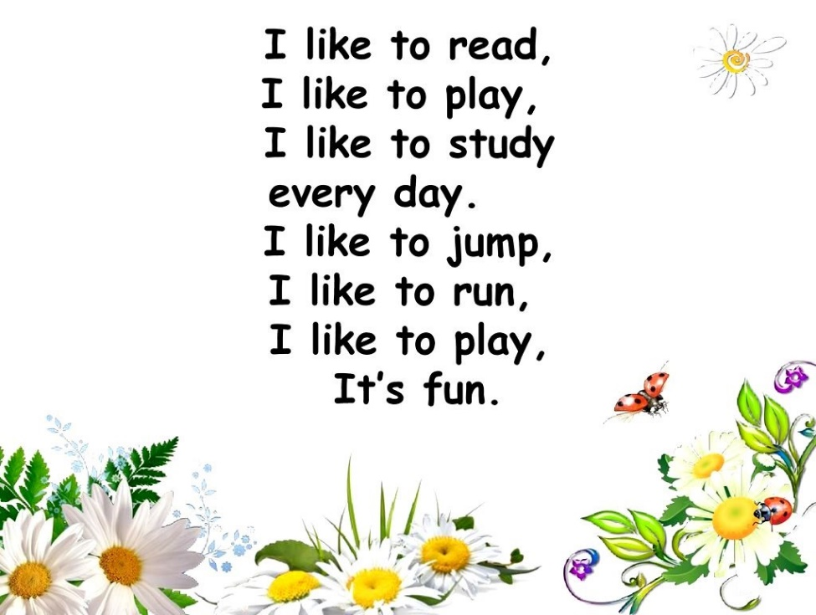

But every day my father’s in despair, he just sits on a chair.

**King:**

My little daughter needs a mother and this is my new wife.

**Narrator;**

The king gets married. She is beautiful and evil and she has a wicked heart. She asks her secret mirror to find the prettiest one.

**Queen**:

Magic Mirror in my hand,

Who’s the prettiest one on land?

**Magic Mirror**:

I cannot lie, so I must say, you are the prettiest one today!

**Narrator:**

To hear that, she is pleased and feels the power. For 16 years the mirror tells the same. Snow White is growing fast and is not a little child any more.

**Snow White:**

How lovely is the place where I live and people all around, but there is the one who hates me, is my so called “stepmother”.

**Narrator:** And one day….

**Queen**:

Magic Mirror in my hand,

Who’s the prettiest one on land?

**Magic Mirror:** I cannot lie, so I must say, Snow White is the prettiest today!

The skin as white as snow, the hair is as black as resin and the lips’re as red as rose.

**Queen**:

”What are you saying, mirror? Snow White?! That cannot be!

I know the girl is pretty, but prettier than me?”

**Narrator:**

The Queen goes absolutely wild.  
She yells, ‘I’m going to scrag that child!

She calls the huntsman strictly

To take her to the forest deeply.

**The Huntsman:**

My Majesty, I’m your faithful servant. What do you call me for?

**Queen**:

Let me never see Snow White again. Take her to the forest, leave her alone and let her suffer there. Be sure, I’ll reward your generously.

**The Huntsman:**

Yes, my Majesty! I’ll serve you faithfully!

**Narrator:**

The Huntsman dragged the lovely child  
Deep, deep into the forest wild.

**The Huntsman:**

My princess, I’ve known you since childhood and don’t want to hurt you at any case, but there is a great danger! Please, run, run away as far as possible, as fast as possible!

**Snow White:**

I will run and the Queen will never find me. Thank you for your faith.

**Narrator:** While she is running, the heart is beating.

**Snow White:**

"I'm cold and all alone."

**Narrator:**

She walks and walks for hours and finds a little lovely home.

**Snow White:**

Oh, *What a lovely little housel*

*But no one is inside! I’ll knock 3 times and come inside.*

**Narrator:**

Snow White pushes the door and opens it. The house outside looks small and lovely, but inside it’s messy and untidy!

**Snow White:**

Oh, how small it looks! There is dust everywhere! And how many different little things are there! Oh, It’s a kitchen. There is a table and there are 7 chairs: one, two, three, four, five, six, seven. There are 7 plates. There are 7 cups. There are 7 spoons. There are 7 forks. There are 7 pairs of slippers.

Ugh, spider web is everywhere. Who can live in such a dust? I should clean it up at once!

Dance and song. “Swish, swish, swish the living room”

**Snow White:**

Now it’s clean and tidy, the right time to dine. I’ll put on the slippers. I’ll eat the apple and have the teatime.

**Narrator:**

Snow White is very sleepy. She needs a little rest.

**Snow White:**

"I’d better go upstairs to look for any beds.”

There are 7 tiny beds and cushions. All the cushions have funny names: Sneezy, Sleepy, Bashful, Happy, Doc, Grumpy, Dopey. Who are they, these funny little creatures?

"l need a bed to sleep on. Ah yes! This is the best!"

**Narrator:**

By the time 7 dwarfs are coming back.

Song: “Hi/Ho – it’s home, from work we go.

**Narrator:**

They’ve entered the house and they are shocked.

**The Dwarfs:**

**The First Dwarf:**

Look! The house is clean and tidy and there is no spider web.

**The Second Dwarf:**

Who has been here?

**The Third Dwarf:**

Who has done it?

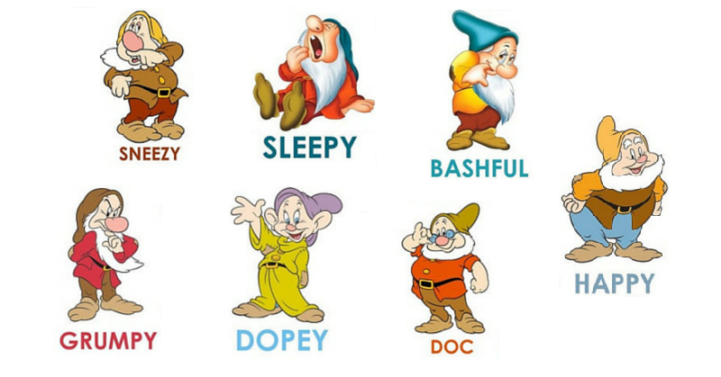

**The First Dwarf:**

Who has been sitting on my chair?

**The Second Dwarf:**

Who has eaten the apples from my plate?

**The Third Dwarf:**

Who has eaten with my fork?

**The Fourth Dwarf:**

And who has had tea from my cup?

**The Fifth Dwarf**:

Who has put on my slippers?

**The Dwarfs:**

**The First Dwarf: Strange!**

**The Second Dwarf: Ridiculous!**

**The Third Dwarf: Unbelievable!**

**The Fourth Dwarf: Mysterious!**

**The Fifth Dwarf: Weird!**

**The Sixth: Frightening!**

**The seventh! All right!**

**Narrator:**

The dwarfs are going up.

**The Dwarfs:**

**The First Dwarf:** Look!

**The Second Dwarf:** This is a very lovely girl!

**The Third Dwarf:** "Why is she here tonight?"

**The Fourth Dwarf:** "Oh, look at all her ribbons!"

**The Fifth Dwarf:** "And what a pretty dress!"

**The Sixth Dwarf:** "Her skin is white like snowflakes!"

**The Seventh Dwarf:** "She must be a princess!

**The First Dwarf:** "Look! She's waking up now."

**The Second Dwarf:** 'Please tell us where you come from."

**The Third Dwarf:** "And tell us why you're here! "

**Snow White:**

"My father's wife is evil and she has a wicked heart,

She wants to scrab me out of my father’s heart.

**The Dwarfs:**

**The First Dwarf:** *"Don't worry!*

**The Second Dwarf:**  *You can hide here.*

**The Third Dwarf:**  *Your stepmother’s for away!"*

**Snow White:**

"Oh, thank you! I'm so happy that I can stay! But, can I guess who you are?

**The Dwarfs:**

*We are 7 funny dwarfs.*

**The First Dwarf:** I am Sneezy and I can smell easy.

**The Second Dwarf:**  *I am Sleepy and I always sleep sweetly.*

**The Third Dwarf:**  *I am Bashful …*

**The Fourth Dwarf:**  *I am Happy and I am always very snappy.*

**The Fifth Dwarf:**  *I am Doc and I know the value of clock.*

**The Sixth Dwarf:** *I am Dopey and I always play hooky.*

**The Seventh Dwarf:** *I am Grumpy and I am always hungry.*

**Narrator:**

Snow White and 7 dwarfs live happily and merrily. She does the cleaning and cooking while they are at work.

**The Dwarfs:**

**The First Dwarf:** We are going to work!

**The Second Dwarf:** Be careful!

**The Third Dwarf:** Take care!

**The Fourth Dwarf:** Stay inside the house!

**The Fifth Dwarf:** Don’t open the door!

**The Sixth Dwarf:** Don’t talk to the strangers!

**The Seventh Dwarf:** Wait for us! Have a great day!

**Narrator:**

The dwarfs have gone and Snow White is left alone. By the time Snow White’s stepmother discovers the truth.

**Queen**:

Magic Mirror in my hand,

Who’s the prettiest one on land?

**Magic Mirror:** I cannot lie, so I must say, Snow White is the prettiest today!

"Over the hills and far away, she lives with seven dwarfs this day!"

**Queen:**

What are you saying, mirror? Snow White?! That cannot be true!

The Huntsman has cheated me!

"Just wait and see, Snow White!

**Narrator:**

The Queen poisons the apple and puts on a black cloak. She is going to Snow White.

**Snow White:**

Who is knocking at my door?

**Queen:**

I’m an old lady and I’d like to treat you with the apple! Look! It’s so yummy and sweet! Try it, please!

**Snow White:**

Oh! Thank you!

**Narrator:**

She takes a bite and falls down on the bed.

**Queen:**

The apple is full of poison. White as snow, red as blood!

The dwarfs will never wake you up!

**Narrator:**

The Queen runs away. The dwarfs are coming back. They can see Snow White is on the bed without any movements.

**The Dwarfs:**

**The First Dwarf**: The wicked stepmother has found her.

**The Second Dwarf**: She has poisoned Snow White.

**The Third Dwarf:** Her cheeks are so rosy as a rose!

**The Fourth Dwarf:** She looks as if she’s just sleeping!

**The Fifth Dwarf:** Let’s put her in a glass case!

**The Sixth Dwarf:** There is just a spell on her!

**The Seventh Dwarf:**

I’m sure, a handsome prince is on his way.

He's on a big white horse.

His magic kiss will wake her up.

And break the spell, of course!

**Narrator:**

One day there is a prince by the glass case.

**The Prince:**

Who is this beautiful girl?

**The Fifth Dwarf:**

Her name is Snow White. She is a princess.

**The Prince:**

I’m prince Henry. She looks so very pretty!" I’ll give Snow White a kiss.

**The Dwarfs:**

***The First Dwarf:*** *Look!*Her eyes are open!"

***The Second Dwarf:*** " I think that she's all right!"

***The Third Dwarf:*** They are a great couple.

***The Fourth Dwarf:*** They’ll marry each other tonight!

**Narrator:**

Snow White goes with Prince Henry and takes her seven friends.

Now everybody's happy and so, this is the END!

**They sing a song**:

Make new friends,

but keep the old.

One is silver,

the other is gold.

A circle is round,

it has no end.

That's how long,

I will be your friend.

A fire burns bright,

it warms the heart.

We've been friends,

from the very start.

You have one hand,

I have the other.

Put them together,

We have each other.

Silver is precious,

Gold is too.

I am precious,

and so are you.

You help me,

and I'll help you

and together

we will see it through.

The sky is blue

The Earth is green

I can help

to keep it clean

Across the land

Across the sea

Friends forever

We will always be

|  |  |  |  |
| --- | --- | --- | --- |
| **They sing a song**:  Make new friends,  but keep the old.  One is silver,  the other is gold.  A circle is round,  it has no end.  That's how long,  I will be your friend.  A fire burns bright,  it warms the heart.  We've been friends,  from the very start.  You have one hand,  I have the other.  Put them together,  We have each other.  Silver is precious,  Gold is too.  I am precious,  and so are you.  You help me,  and I'll help you  and together  we will see it through.  The sky is blue  The Earth is green  I can help  to keep it clean  Across the land  Across the sea  Friends forever  We will always be | **They sing a song**:  Make new friends,  but keep the old.  One is silver,  the other is gold.  A circle is round,  it has no end.  That's how long,  I will be your friend.  A fire burns bright,  it warms the heart.  We've been friends,  from the very start.  You have one hand,  I have the other.  Put them together,  We have each other.  Silver is precious,  Gold is too.  I am precious,  and so are you.  You help me,  and I'll help you  and together  we will see it through.  The sky is blue  The Earth is green  I can help  to keep it clean  Across the land  Across the sea  Friends forever  We will always be | **They sing a song**:  Make new friends,  but keep the old.  One is silver,  the other is gold.  A circle is round,  it has no end.  That's how long,  I will be your friend.  A fire burns bright,  it warms the heart.  We've been friends,  from the very start.  You have one hand,  I have the other.  Put them together,  We have each other.  Silver is precious,  Gold is too.  I am precious,  and so are you.  You help me,  and I'll help you  and together  we will see it through.  The sky is blue  The Earth is green  I can help  to keep it clean  Across the land  Across the sea  Friends forever  We will always be | **They sing a song**:  Make new friends,  but keep the old.  One is silver,  the other is gold.  A circle is round,  it has no end.  That's how long,  I will be your friend.  A fire burns bright,  it warms the heart.  We've been friends,  from the very start.  You have one hand,  I have the other.  Put them together,  We have each other.  Silver is precious,  Gold is too.  I am precious,  and so are you.  You help me,  and I'll help you  and together  we will see it through.  The sky is blue  The Earth is green  I can help  to keep it clean  Across the land  Across the sea  Friends forever  We will always be |