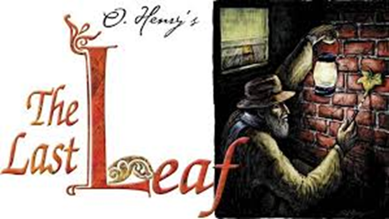

**WORKBOOK**

(Рабочая тетрадь для учителя английского языка для организации работы

с новеллой американского прозаика О.Генри «Последний лист»)

Cеребрякова В.А., учитель английского языка ГОУ «Забайкальский краевой лицей-интернат», Заслуженный учитель РФ.

Workbook «The last leaf»: рабочая тетрадь для учителя по курсу «Английская литература»

Предлагаемая рабочая тетрадь предназначена для организации работы с произведением О.Генри «Последний лист». Работу можно организовать в рамках элективного курса «Английская литература», на уроках домашнего чтения в старших классах или внеурочной деятельности по английскому языку. Учитель вправе выбрать любые упражнения, предлагаемые авторами данной рабочей тетради.

Апробация рабочей тетради проводилась авторами на базе двух образовательных учреждений г. Читы, а именно ГОУ «Забайкальский краевой лицей-интернат» и МБОУ «Средняя общеобразовательная школа №49 с углубленным изучением английского языка им. Героя РФ Е.А. Секержитского».

Рецензенты:

Спиридонова А.В., заместитель директора Читинского педагогического колледжа, к.п.н.

Суворова Б.С., учитель английского языка МБОУ «Средняя общеобразовательная школа №49 с углубленным изучением английского языка им. Героя РФ Е.А. Секержитского».

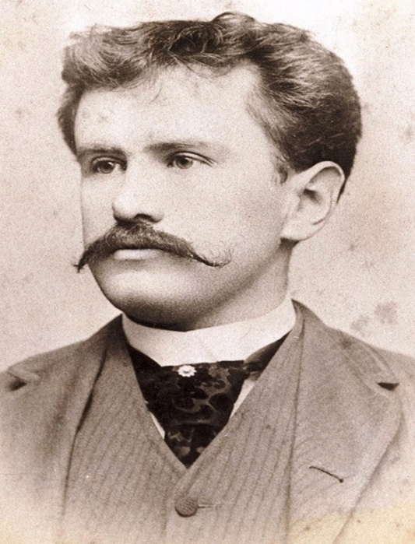 **O. Henry**

Thе real name of the writer O. Henry was William Sydney Porter. He was born in a small town Greensboro in the USA (the state of North Carolina) in the family of a doctor. He was brought up by his aunt because his mother died when he was a small boy. After finishing school at the age of fifteen, Porter worked in his uncle’s chemist shop in Greensboro. Then he went to Texas because he wanted to see new places. For two years he worked on a farm, then he became a clerk in an office and at last got a job in a small bank. During this period, he studied languages and became interested in literature.

Soon he married Athol Roach; they had a daughter. Porter was a happy husband and father, but his happiness did not last long. One day a theft of a thousand dollars was discovered at the bank where he worked. Though it was not he who had taken the money, Porter left the town and went to Central America where he stayed for some time. But when he heard that his wife was very ill, he returned home but was immediately put into prison for three years. His wife died and his little daughter was raised by the relatives. The little girl was told that her father had gone very far away and would not return soon.

In prison William often thought about her and was very sorry that she would not receive a Christmas present from him that year. Porter decided to write a story and send it to one of the American magazines to get some money for a present. The story called «Whistling Dick’s Christmas Present» was published in 1899. Porter had signed it «O. Henry» — the first pen-name that came into his head. While still in prison, he published many other stories. In 1901, when he was released from prison, he settled in New York, and continued writing short stories for different magazines. Very soon he became one of the most popular short-story writers in America.

O. Henry’s stories won great popularity and have been translated into many languages. Most of them have unexpected endings and the reader is always taken by surprise. During the short period of his literary activity, O. Henry wrote 273 short stories and one novel «Cabbages and Kings» (1904). In his stories O. Henry describes amusing incidents of everyday life in large cities, on the farms, and on the roads of America. In most of his stories he does not touch upon important social problems, but the author’s sympathy is with the common people of America, whose life he knew very well. His greatest wish was that people should be happy.

***T h e L a s t L e a f***

In a small part of the city west of Washington Square, the streets have gone wild. They turn in different directions. They are broken into small pieces called “places”. One street goes across itself one or two times. A painter once discovered

something possible and valuable about this street. Suppose a painter had some painting materials for which he had not paid. Suppose he had no money. Suppose a man came to get the money. The man might walk down that street and suddenly meet himself coming back, without having received a cent!

This part of the city is called Greenwich Village. And to old Greenwich Village the painters soon came. Here they found rooms they like, with good light and at a low cost.

Sue and Johnsy lived at the top of a building with three floors. One of these young women came from Maine, the other from California. They had met at a restaurant on Eighth Street. There they discovered that they liked the same kind of art, the same kind of food, and the same kind of clothes. So they decided to live and work together. That was in the spring.

Toward winter a cold stranger entered Greenwich Village. No one could see him. He walked around touching one person here and another there with his icy fingers. He was a bad sickness. Doctors called him Pneumonia. On the east side of the city he hurried, touching many people; but in the narrow streets of Greenwich Village he did not move so quickly.

Mr. Pneumonia was not a nice old gentleman. A nice old gentleman would not hurt a weak little woman from California. But Mr. Pneumonia touched Johnsy with his cold fingers. She lay on her bed almost without moving, and she looked through the window at the wall of the house next to hers.

One morning the busy doctor spoke to Sue alone in the hall, where Johnsy could not hear.

“She has a very small chance,” he said. “She has a chance, if she wants to live. If people don’t want to live, I can’t do much for them. Your little lady has decided that she is not going to get well. Is there something that is troubling her?”

“She always wanted to go to Italy and paint a picture of the Bay of Naples,” said Sue.

“Paint! Not paint. Is there anything worth being troubled about? A man?”

“A man?” said Sue. “Is a man worth—No, doctor. There is not a man.”

“It is weakness,” said the doctor. “I will do all I know how to do. But when a sick person begins to feel that he’s going to die, half my work is useless. Talk to her about new winter clothes. If she were interested in the future, her chances would be better.”

After the doctor had gone, Sue went into the workroom to cry. Then she walked into Johnsy’s room. She carried some of her painting materials, and she was singing.

Johnsy lay there, very thin and very quiet. Her face was turned toward the window. Sue stopped singing, thinking that Johnsy was asleep.

Sue began to work. As she worked, she heard a low sound, again and again. She went quickly to the bedside.

Johnsy’s eyes were open wide. She was looking out the window and counting—counting back.

“Twelve,” she said; and a little later, “Eleven”; and then, “Ten,” and, “Nine”; and then, “Eight,” and, “Seven,” almost together.

Sue looked out the window. What was there to count? There was only the side wall of the next house, a short distance away. The wall had no window. An old, old tree grew against the wall. The cold breath of winter had already touched it. Almost all its leaves had fallen from its dark branches.

“What is it, dear?” asked Sue.

“Six,” said Johnsy, in a voice still lower. “They’re falling faster now.

Three days ago, there were almost a hundred. It hurt my head to count them. But now it’s easy. There goes another one. There are only five now.”

“Five what, dear? Tell your Sue.”

“Leaves. On the tree. When the last one falls, I must go, too. I’ve known that for three days. Didn’t the doctor tell you?”

“Oh, I never heard of such a thing,” said Sue. “It doesn’t have any sense in it. What does an old tree have to do with you? Or with your getting well? And you used to love that tree so much. Don’t be a little fool. The doctor told me your chances for getting well. He told me this morning. He said you had very good chances! Try to eat a little now.

And then I’ll go back to work. And then I can sell my picture, and then I can buy something more for you to eat to make you strong.”

“You don’t have to buy anything for me,” said Johnsy. She still looked out the window. “There goes another. No, I don’t want anything to eat. Now there are four. I want to see the last one fall before night. Then I’ll go, too.”

“Johnsy, dear,” said Sue, “will you promise me to close your eyes and keep them closed? Will you promise not to look out the window until I finish working? I must have this picture ready tomorrow. I need the light; I can’t cover the window.”

“Couldn’t you work in the other room?” asked Johnsy coldly.

“I’d rather be here by you,” said Sue. “And I don’t want you to look at those leaves.”

“Tell me as soon as you have finished,” said Johnsy. She closed her eyes and lay white and still. “Because I want to see the last leaf fall. I have done enough waiting. I have done enough thinking. I want to go sailing down, down, like one of those leaves.”

“Try to sleep,” said Sue. “I must call Behrman to come up here. I want to paint a man in this picture, and I’ll make him look like Behrman.

I won’t be gone a minute. Don’t try to move till I come back.”

Old Behrman was a painter who lived on the first floor of their house. He was past sixty. He had had no success as a painter. For forty years he had painted, without ever painting a good picture. He had always talked of painting a great picture, a masterpiece, but he had never yet started it.

He got a little money by letting others paint pictures of him. He drank too much. He still talked of his great masterpiece. And he believed that it was his special duty to do everything possible to help Sue and Johnsy.

Sue found him in his dark room, and she knew that he had been drinking. She could smell it. She told him about Johnsy and the leaves on the vine. She said that she was afraid that Johnsy would indeed sail down, down like the leaf. Her hold on the world was growing weaker.

Old Behrman shouted his anger over such an idea.

“What!” he cried. “Are there such fools? Do people die because leaves drop off a tree? I have not heard of such a thing. No, I will not come up and sit while you make a picture of me. Why do you allow her to think such a thing? That poor little Johnsy!”

“She is very sick and weak,” said Sue. “The sickness has put these strange ideas into her mind. Mr. Behrman, if you won’t come, you won’t. But I don’t think you’re very nice.”

“This is like a woman!” shouted Behrman. “Who said I will not come? Go. I come with you. For half an hour I have been trying to say that I will come. God! This is not any place for someone so good as

Johnsy to lie sick. Some day, I shall paint my masterpiece, and we shall

all go away from here. God! Yes.”

Johnsy was sleeping when they went up. Sue covered the window, and took Behrman into the other room. There they looked out the window fearfully at the tree. Then they looked at each other for a moment without speaking. A cold rain was falling, with a little snow in it too.

Behrman sat down, and Sue began to paint.

She worked through most of the night.

In the morning, after an hour’s sleep, she went to Johnsy’s bedside. Johnsy with wide-open eyes was looking toward the window. “I want to see,” she told Sue.

Sue took the cover from the window.

But after the beating rain and the wild wind that had not stopped through the whole night, there still was one leaf to be seen against the wall. It was the last on the tree. It was still dark green near the branch. But at the edges it was turning yellow with age. There it was hanging from a branch nearly twenty feet above the ground.

“It is the last one,” said Johnsy. “I thought it would surely fall during the night. I heard the wind. It will fall today, and I shall die at the same time.”

“Dear, dear Johnsy!” said Sue. “Think of me, if you won’t think of yourself. What would I do?”

But Johnsy did not answer. The loneliest thing in the world is a soul when it is preparing to go on its far journey. The ties that held her to friendship and to earth were breaking, one by one.

The day slowly passed. As it grew dark, they could still see the leaf hanging from its branch against the wall. And then, as the night came, the north wind began again to blow. The rain still beat against the windows.

When it was light enough the next morning, Johnsy again commanded that she be allowed to see.

The leaf was still there.

Johnsy lay for a long time looking at it. And then she called to Sue, who was cooking something for her to eat.

“I’ve been a bad girl, Sue,” said Johnsy. “Something has made that last leaf stay there to show me how bad I was. It is wrong to want to die. I’ll try to eat now. But first bring me a looking-glass, so that I can see myself. And then I’ll sit up and watch you cook.”

An hour later she said, “Sue, some day, I hope to paint the Bay of Naples.”

The doctor came in the afternoon. Sue followed him into the hall outside Johnsy’s room to talk to him.

“The chances are good,” said the doctor. He took Sue’s thin, shaking hand in his. “Give her good care, and she’ll get well. And now I must see another sick person in this house. His name is Behrman. A painter, I believe. Pneumonia, too. Mike is an old, weak man, and he is very ill. There is no hope for him. But we take him to the hospital today. We’ll make it as easy for him as we can.”

The next day the doctor said to Sue: “She’s safe. You have done it. Food and care now—that’s all.”

And that afternoon Sue came to the bed where Johnsy lay. She put one arm around her.

“I have something to tell you,” she said. “Mr. Behrman died of pneumonia today in the hospital. He was ill only two days. Someone found him on the morning of the first day, in his room. He was helpless with pain.”

“His shoes and his clothes were wet and as cold as ice. Everyone wondered where he had been. The night had been so cold and wild.

“And then they found some things. There was a light that he had taken outside. And there were his materials for painting. There was paint, green paint and yellow paint. And—

“Look out the window, dear, at the last leaf on the wall. Didn’t you wonder why it never moved when the wind was blowing? Oh, my dear, it is Behrman’s great masterpiece—he painted it there the night that the last leaf fell.

**Учебные задания для работы с произведением**

**A) Пред текстовый этап**

1) O. Henry is a famous American short-story writer. Read the description of  
the text’s author.

**O. Henry**, pseudonym of **William Sydney Porter** (11.09.1862 –  
05.06.1910), is an American short-story writer whose tales romanticized the life of  
ordinary people in New York City. His stories expressed the effect of coincidence  
on character through humour, grim or ironic, and often had surprise endings, a  
device that became identified with his name and cost him critical favour when its  
vogue had passed.

Despite his popularity, O. Henry’s final years were unhappy. After his death  
many of his collections and early works were published. Foreign translations  
and adaptations for other art forms, including films and television, show his  
universal application and appeal. The O. Henry Prize, given annually to  
outstanding short stories, was established in his honour in 1919.  
 В данном задании делается акцент на биографии автора, для того,  
чтобы студенты могли лучше представить себе этого человека, его  
популярность и особенность произведений.

2) Read the title of the story. What do you think the story will be about? In  
your opinion, what does “the last leaf” associate with?  
 ***Комментарии к заданию***:

Данное задание направлено на формирование языковой догадки.  
Обсуждение этих вопросов также может повысить мотивацию к прочтению  
текста.

3) Работа с лексикой

**Essential Vocabulary**

Bill (n) – a request for payment of money owed, or the piece of paper on  
which it is written;

To prowl (v) – to move around quietly in a place trying not to be seen or  
heard, such as an animal does when hunting;

Gable (n) – the top end of the wall of a building, in the shape of a triangle,  
where it meets the sloping parts of a roof;

Chafing dish (n) – a metal dish used for serving food that has a small flame  
under it to keep the food warm;

Table d'hôte (n) – food that is served in a restaurant as a complete meal at  
a fixed price but with little choice of dishes;

Ravager (n) – a person or thing that works havoc or does great damage;  
 Duffer (n) – a person who is stupid or unable to do anything well;

Undertaker (n) – a person whose job is to prepare the bodies of dead people  
to be buried or cremated, and to arrange funerals;

Jew's harp (n) – a small musical instrument that is held between the teeth  
and played by hitting a metal strip with the finger;

Ragtime (n) – an early form of jazz, especially for the piano, first played by  
African American musicians in the early 1900s;

Solicitously (adv) – in a way that shows that you are very concerned for  
somebody and want to make sure that they are comfortable, well or happy;  
Ivy (n) – a climbing plant, especially one with dark green shiny leaves with  
five points;

Broth (n) – thick soup made by boiling meat or fish and vegetables in water;  
Failure (n) – a person or thing that is not successful;

Juniper (n) – a small evergreen bush with sharp leaves and small purple  
fruits that are used in medicine and in making gin;

Den (n) – a room in a house where a person can work or study without being  
interrupted;

To mingle (v) – to mix with, combine;

Hermit (n) – a person who lives alone and apart from the rest of society;

Tinted (adj) – with colour added;

To knit (v) – to make clothes, etc. by using two long needles to connect wool  
or another type of thread into joined rows;

Dreadful (adj) – causing fear or shock.

***Комментарии к заданию***:

**Greenwich Village** is a district of Manhattan where many artists, writers and  
students live and meet in the galleries, cafes, bars and clubs.  
**Pneumonia** is an inflammation (воспаление) of the lungs; its symptoms  
typically include some combination of cough, chest pain, fever, and difficulty  
breathing. During the late 1800s and early 1900s, pneumonia was the leading cause  
of death due to infectious disease and the third leading cause of death overall.

**Задание во время прочтения текста**

Read the following text and mark the equivalents to the following phrases:

эти «проулки» образуют странные углы; своеобразный и  
старомодный Гринвич-Виллидж; несколько кружек из пьютера; широкий  
трёхэтажный дом; поражал своих жертв в больших количествах;  
калифорнийские ветра; едва шевелясь; вставать на сторону гробовщика;  
новые зимние фасоны рукавов; заплакать японскую салфетку; пустой,  
унылый двор; цеплялась за рассыпающиеся кирпичи; с великолепным  
презрением; продать картину редактору; я хочу отпустить всё; нарисовать  
мазню в рекламе; считал себя сторожевым псом; сильно пахнуть  
можжевельником; рассказать о фантазии Джонси; старый болтун; листья  
падают с проклятого плюща; спустить штору до подоконника; уставшие,  
тусклые, широко открытые глаза; с удовольствием вязать; разбросанные  
кисти.

**Упражнения на проверку понимания текста:**

**1. Answer the following questions using the information given in the text  
and the notes:**

1) Where and when does the story take place? 2) How did Johnsy  
and Sue meet? 3) What was Sue doing in Johnsy’s room? 4) When did Johnsy  
think she was going to die? 5) What did Sue ask Johnsy to do while she was busy?  
6) Who is Behrman? 7) How did Behrman react to what Sue had told him? 8) In  
the end, did Behrman manage to paint a masterpiece?

**2. Mark the sentences as true or false. If the sentences are false, correct them.**1. Sue was from California and Johnsy was from Maine.  
2. Johnsy caught pneumonia.  
3. The doctor said that the chances of Sue’s survival were low.  
4. Johnsy was counting leaves on an old oak.  
5. Behrman was a very successful artist.  
6. Behrman worked as a model for Sue.  
7. Behrman died of old age.  
8. The last leaf was painted on the window.

**После текстовый этап**

1) Behrman is, perhaps, the most important character of this story. What is  
he like? Describe the following:  
- his appearance;  
- his job;  
- his attitude towards the other characters of the story;  
- your own opinion on this character.  
 2) Imagine that you are one of Johnsy’s friends / relatives. Try to write a  
letter to her and convince her not to let go of her life. Write the following:  
- introduce yourself;  
- express your concern about her health;  
- give 1-2 reasons why Johnsy must live (painting the Bay of Naples, family,  
friends, future etc.).  
 3) Using the following keywords, retell the text in reported speech: meet,  
pneumonia, chance, cry, count, leave, pose, wake up, last leaf, doctor, die,  
masterpiece.

4) Find the description of the following pictures in the text

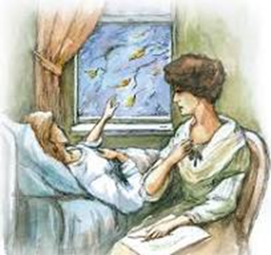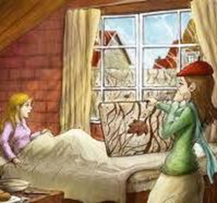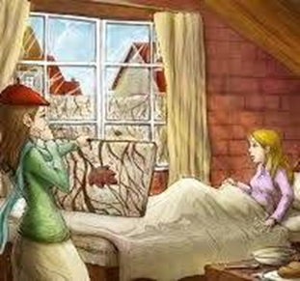

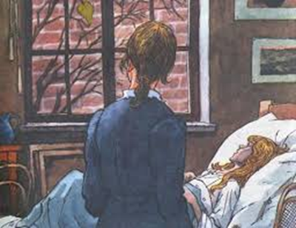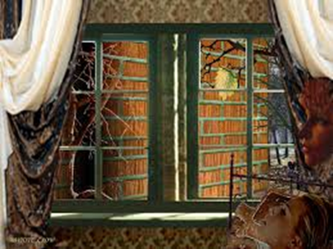



**Заключительный этап**

Просмотр короткометражного художественного фильма «The last leaf»

Рекомендуемые этапы работы:

1. Пред демонстрационный (подготовительный этап)

Целями данного этапа является: создание установки на просмотр, формирование активности учащихся для восприятия информации фильма. На данном этапе могут быть использованы следующие типы заданий:

**Упражнения, направленные на развитие устно-речевых умений**

1. Наличие звука без изображения. Задание учащимся: «Listen to the episode from a movie and answer some questions “Where are the heroes? Who is speaking in this excerpt of the film? What is the mood of the hero? Is he sad/cheerful?”
2. Кнопка «Пауза».

**Комментарии к заданию:**

Этот тип упражнений направлен на высказывание предположений о дальнейшем ходе событий, а также описание просмотренного видеофрагмента.

* What do you think will happen next? Describe the place you saw in the last excerpt. What will the hero say? How will he react? What do you think?
* Imagine that you are the main character. What do you say in this situation? What are the characters talking about? Describe the place you see. Imagine that you are the main character.

**После демонстрационный этап**

1. Вопросно-ответные упражнения по содержанию фильма

Did you like the movie? Argue your opinion. What was the most interesting thing in the film? Which expressions to the film are correct? Who is saying these sentences?

1. Упражнения для развития умений устной речи

* Imagine that you are the hero of a movie. Tell us about the action of the film.
* «Диалог»: Imagine that you are the hero of a movie. Tell us about the action of the film. Describe the main problem of the film. "Dialogue". Stage a dialogue between the characters.
* «Предсказание»

Это задание можно выполнять несколько раз на протяжении фильма: остановите просмотр на «самом интересном месте» и спросите учеников: What will happen next?"

* «Без картинки»
* Это прием, обратный «озвучке». Выберите фрагмент фильма, который можно только прослушать, например, насыщенный диалог. Ученики сами станут актерами: они придумают и инсценируют действие фильма, основываясь на услышанном. Надо следить за тем, чтобы, обсуждая задание, они общались только на иностранном языке.
* «Стоп-кадр» — это работа с дaнной картинкой из фильма. Если вы используете фотографии на уроках, вам будет легко придумать вопросы и для этого задания. Можно разбить учеников на пары и показать кадр только одному из двоих. Его заданием будет описать второму картинку, а тот должен помогать, задавая наводящие вопросы, и схематично зарисовать этот кадр.
* « По мотивам... »

После просмотра фильма группа учеников должна разыграть между собой одну из его сцен или придумать и инсценировать продолжение фильма.

* Просмотр видеофрагмента без звука. Данные упражнения основаны на описании, предугадывании диалогов/монологов, озвучивании.

**Упражнения, направленные на развитие умений письменной речи**

* Imagine that you are the hero of a movie. Write a letter to your friend. Tell us what happened. Write a letter to one of the characters in the film. Give him advice. Express your opinion on this topic.
* **Домашнее задание:**

- Написать эссе на тему: «Последний лист»- это символ…»

**Презентация «Turn on the lights, I don't want to go home in the dark.»**

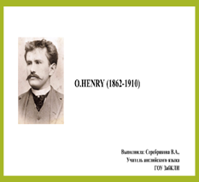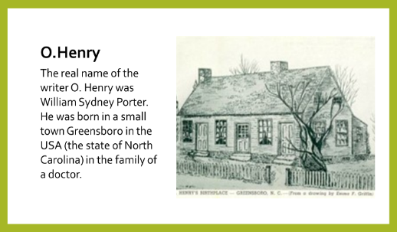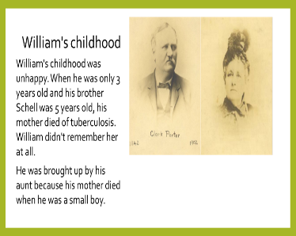

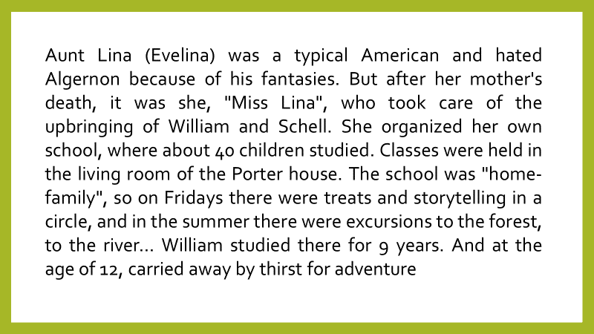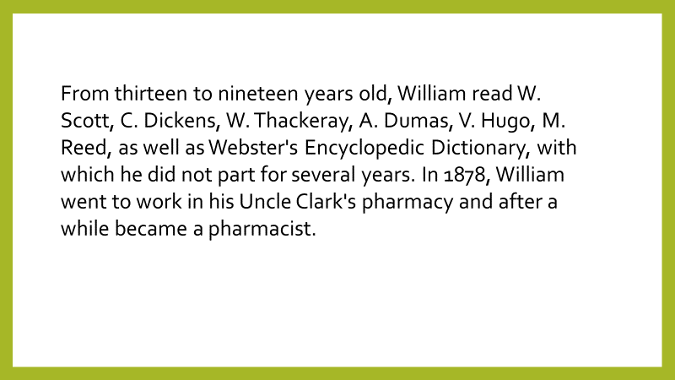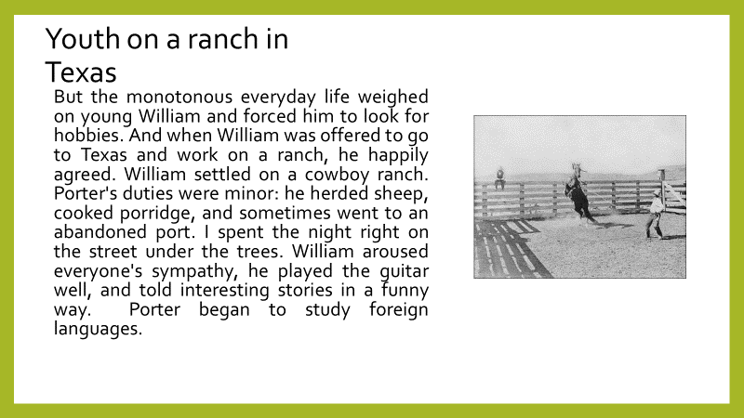

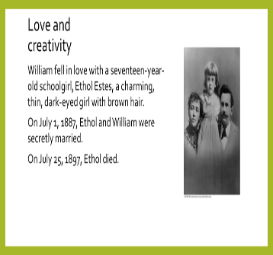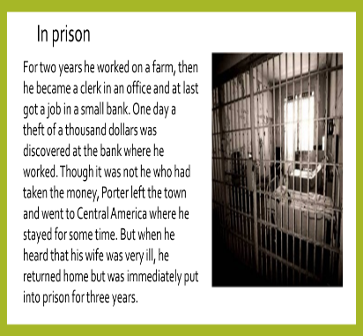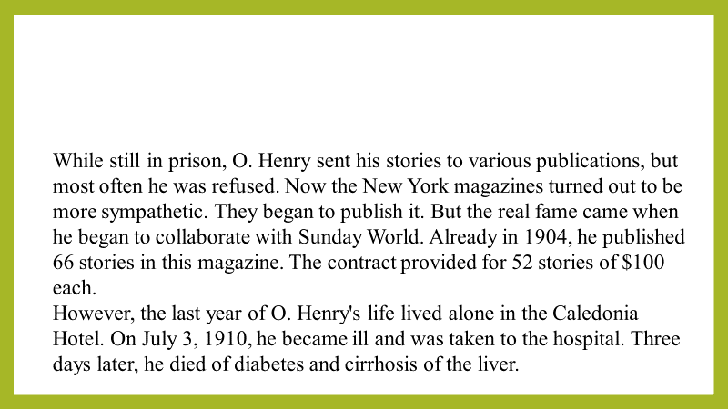 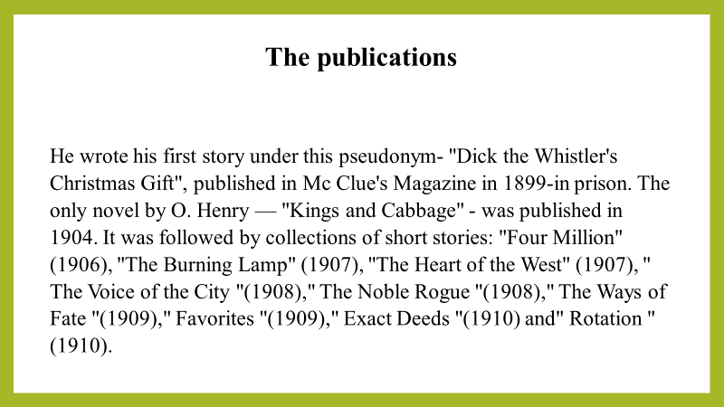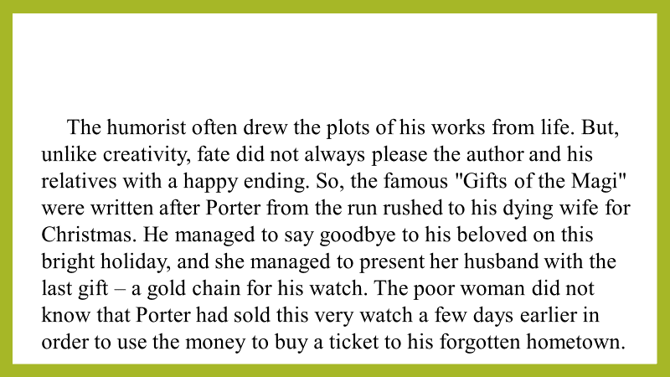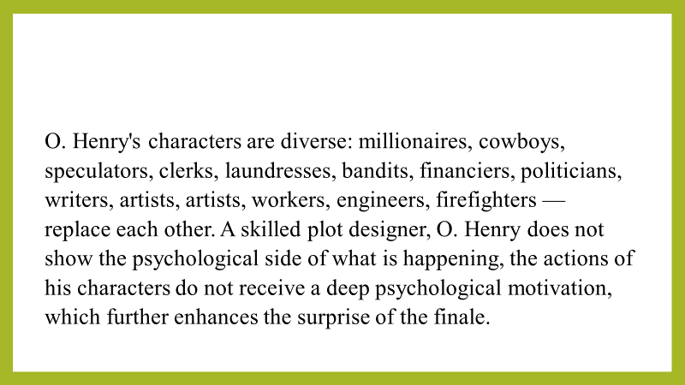

**Список литературы**

- https://englishstory.ru/o-henry-1862-1910-pervoe-znakomstvo.html | Just English Stories

- https://englishstory.ru/biografiya-o-genri.html | Just English Stories

- O. Henry «The Last Leaf»: Selected Stories from O. Henry. Edited by C. Alphonso Smith. – New York: The Odyssey Press, 1922. – 255 c. – C. 141-148).

- Cambridge Dictionary: English Dictionary, Translations and Thesaurus.–

Текст: электронный // dictionary.cambridge.org: [сайт]. – 2023. – URL:

https://dictionary.cambridge.org/. (дата обращения: 21.10.23).71

- Oxford Learner’s Dictionaries. – Текст: электронный // oxfordlearnersdictionaries.com: [сайт]. – 2023. – URL:

- https://www.oxfordlearnersdictionaries.com/. (дата обращения: 21.10.23).

**Содержание**

1. Биография О.Генри…………………………………………..2-3 стр.
2. Новелла «Последний лист»………………………………….4-8 стр.
3. Учебные задания для работы с произведением…………….9-12 стр.
4. Презентация «О.Генри»………………………………………13 стр.
5. Список литературы …………………………………………...14 стр.