
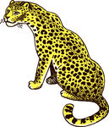
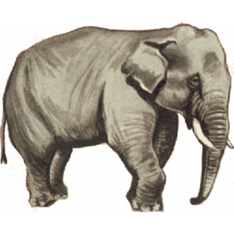

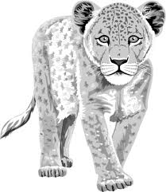


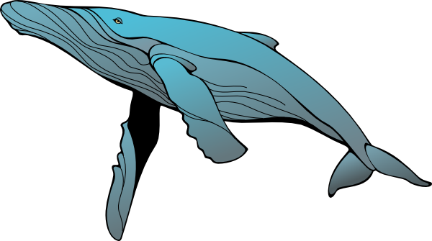

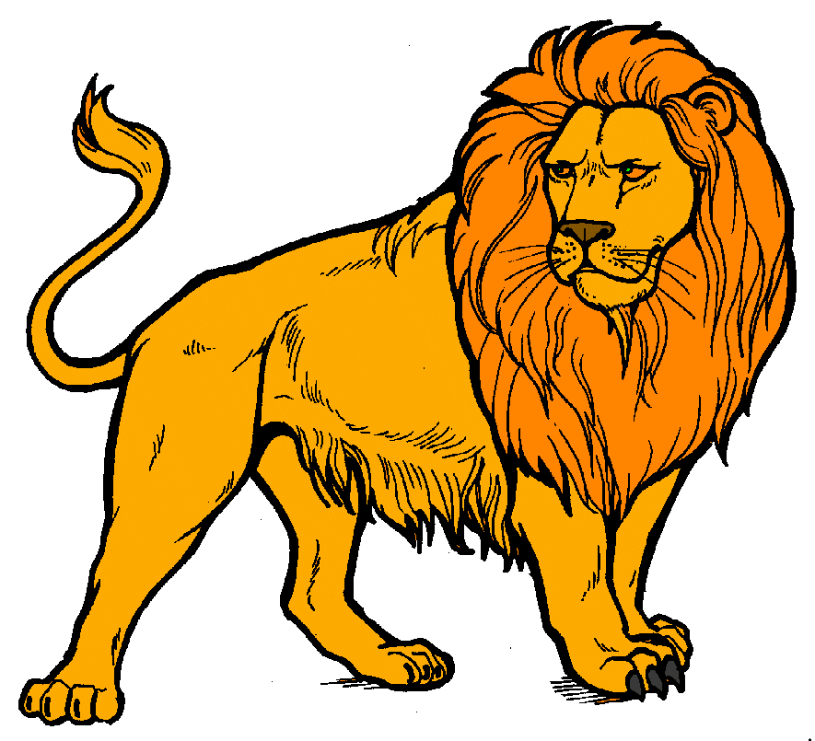

Hello to you all! My name is Debbie Morgan. I am a zoologist and I work to preserve and save endangered species, that is animals which are disappearing from our planet, because of the changes in climate, hunting, or poaching, and the destruction of their habitat. I have just come back from the World Conservation Congress in Hawaii .Do you know that one of the last male white rhino has just died.There are only about 700 mountain gorillas left, 2,000 giant pandas, between 2,000 and 3,000 Bengal tigers, between 7,000 and 10,000 cheetahs , about 130 condors, less than 50 Amur leopards, between 4,000 and 6,600 snow leopards ,about 7,000 orang-utans, 80% of the population of the white shark has disappeared in less than 15 years, 80% of the population of the Irrawaddy dolphin has disappeared in the last 50 years. The Chinese dolphin disappeared in 2006, the giant Pinta tortoise in 2012, 50% of the Asian elephants were exterminated in one century. Many species are nearly extinct in the wild and can only be seen in zoos!!With the ice disappearing at the poles, polar bears are threatened (there are only between 20,000 and 25,000 left). Elephants are killed for the ivory of their tusks, their meat or body parts ( only 350,000 are still alive in Africa), rhinos are killed just for their horns as well , which are reduced to powder and supposed to have medical power. Big cats are killed for their fur, or hunted in safaris for fun! Cecil the most famous lion in Zimbabwe was killed by a Minnesota dentist during a safari!!!! The destruction of big forests leads to the death of many species of animals and plants. And what about whales ??Even the bees are dying massively because of too many pesticides and don’t forget that if they do disappear, men will follow soon after. So it is our responsibility and yours as well, you young generations to do our best to preserve our planet!!
II.ANSWER THE QUESTION. 1.Who is speaking ?What’s her job ?-------------------------------------------------------------------------------------------------------------------2. What is this document about ?-----------------------------------------------------------------------------------------------------------------------3.What are the most endangered animals ?------------------------------------------------------------------------------------------------------------4. Why are Polar bears in danger ?------------------------------------------------------------------------------------------------------------------------------------------------------------------------
5. Why are elephants killed ? --------------------------------------------------------------------------------------------------------------------------6. Why are rhinos killed ?--------------------------------------------------------------------------------------------------------------------------------
I .TRANSLATE IN YOUR OWN LANGUAGE
ENGLISH | NATIVE LANGUAGE---------
Endangered
Habitat
Climate
Hunting
Ivory
Fur
Poaching
Preserve
Species
Threatened
Bees
Everywhere

III .COMPLETE THE FOLLOWING GRID WITH NAMES OF ANIMALS IN THE TEXT AND THE NUMBERS GIVEN FOR EACH OF THEM.
NAMES  OF ANIMALS | mountain gorillas | giant pandas | Bengal tigers | Cheetah | Condors | Amur leopards | snow leopards | orang-utans | polar bears | Elephants
NUMBERS

IV.THINK OF WHAT CAN BE DONE TO PROTECT ANIMALS AND MAKE THREE SUGGESTIONS, THEN CHOOSE AN ANIMAL AS SYMBOL AND CREATE A POSTER WITH A SLOGAN.
----------------------------------------------------------------------------------------------------------------------
----------------------------------------------------------------------------------------------------------------------
----------------------------------------------------------------------------------------------------------------------

POSTER (Drawing)

8 -9 класс
ANSWERS:
1. За каждый правильный ответ -1 балл
Endangered | Находящийся под угрозой
Habitat | Среда обитания
Climate | Климат
Hunting | Охота
Ivory | Слоновая кость, бивни
Fur | Мех
Poaching | Браконьерство
Preserve | Сохранять, охранять.
Species | Виды
Threatened | Под угрозой
Bees | Пчелы
Everywhere | Повсюду, везде
2. За каждый правильный ответ -2 балл
1.Who is speaking ?What’s her job ?- Debbie Morgan is speaking. She is a zoologist
2. What is this document about ? This document is about endangered and disappearing animals, how to preserve our nature. ( preservation of nature)
5.What are the most endangered animals ? The most endangered animals are polar bears, elephants, rhinos, big cats, whales, bees.
6. Why are Polar bears in danger ? Polar bears are in danger because the ice disappearing at the poles.
7. Why are elephants killed ? Elephants are killed for the ivory of their tusks, their meat or body parts.
8. Why are rhinos killed ? Rhinos are killed just for their horns as well , which are reduced to powder and supposed to have medical power.
3. За каждый правильный ответ -1 балл.
NAMES  OF ANIMALS | mountain gorillas | giant pandas | Bengal tigers | Cheetah | Condors | Amur leopards | snow leopards | orang-utans | polar bears | Elephants
NUMBERS | 700 | 2000 | 2000-3000 | 7000-10000 | 130 | >50 | 4000-6600 | 7000 | 20000-25000 | 350000
4. За четвертое задание-3 балла (творческое)
Источник - https://en.islcollective.com/download/english-esl-worksheets/reading-comprehension/reading-for-detail-deep-reading/cardinal-numbers/from-endangered-to-extinct-2-page-updated-reading/91132

