**План-конспект урока**

**на тему "My country" ("Моя страна")**

**в 6 классе**

**Тема:** Моя страна

**Цели:**

**Обучающие**

1. Повторить и закрепить лексику по темам "Страны", "Национальности";
2. Отработать грамматику по теме "Present Simple";
3. Научиться составлять рассказ о своей стране с указанием сторон света.

**Развивающие**

1. Развивать навыки

* аудирования
* говорение
* чтения
* письма

1. Развивать монологическую речь;

**Воспитательные**

1. Воспитать патриотическое отношение к своей стране.

**Задачи:**

1. Описывать свою страну с использованием ранее изученной лексики;
2. Совершенствовать навыки говорения.

**Тип урока:** проверка и коррекция знаний и умений.

**Приемы работы**: парные, индивидуальные, самостоятельная работа с текстом.

**Оборудование урока:** УМК "Spotlight" 6 под редакцией Ю.Е. Ваулиной, Дж. Дули; карточки с флагами разных стран; аудио к тексту учебника.

**Новые слова:**.

**Продолжительность урока:** 40 минут.

**Ход урока**

1. **Организационный момент (3 мин)**

Teacher: Hello, dear pupils.

Ps: Hello, teacher.

Teacher: I'm glad to see you. How are you doing today?

Ps: I'm good, thank you. And you?

Teacher: I'm very well. Thank you. Sit down, please.

Teacher: Tell me, please, what day is it today?

Ps: It's...

Teacher: Yes, you're right. And what date is it today?

Ps: It's...

Teacher: And do you remember what month is it now?

Ps: It's...

Teacher: Very good. How clever you are!

1. **Фонетическая зарядка. Введение в тему (7 мин)**

Teacher: Look at the board. What can you see?

Ps: Flags of different countries.

Teacher: Right you re. Do you know these countries? Let's read the poem and repeat some countries of the world.

*(Ученики читают хором за учителем стих про страны мира)*

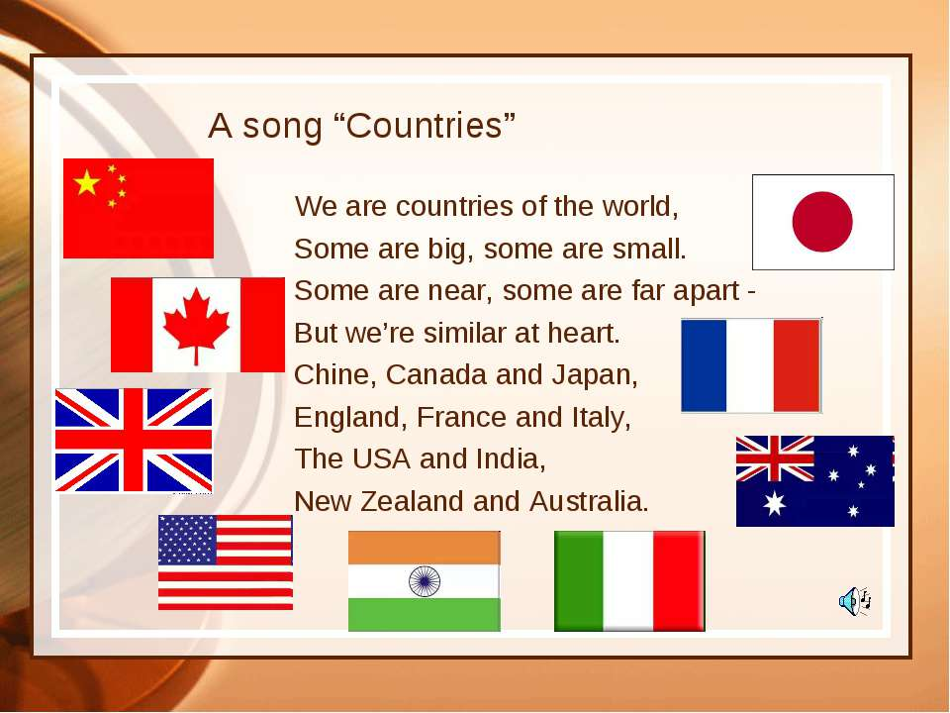

Teacher: There are many countries in the world. Many of them are English speaking countries but do you know what our country in English is?

Ps: Our country is ...

Teacher: Right you are. So, how do you think what the topic of our lesson is?

Ps: The topic of the lesson is my country.

Teacher: How clever you are! Today we are going to revise English speaking countries and to talk about our own country.

**3. Изучение нового материала (23 мин)**

Teacher: Open your books on p. 10 ex. 1a. Look at the picture. You can see two columns - countries and nationalities. Let's read the first column and revise English speaking countries.

*(Ученики хором произносят за учителем страны: Brazil, Britain, Germany, Japan, Poland, Russia, Spain)*

Teacher: Now, let's read the second column and match each country to its nationality.

*(Ученики по очереди читают название национальности и соединяют её с нужной страной)*

Teacher: Very well. Let's listen to the tape recorder and check.

*(Ученики слушают аудио и проверяют, правильно ли они соединили страну с национальностью)*

Teacher: So, pupils, what nationality are you?

Ps: I'm Russian / I'm Ukrainian...

Teacher: Thank you for your answers. Pupils, look at the ex. 2a. Do you know that compass can help you to find the right way where to go? Look at the picture. Letter N means ''north'' (север), letter E means ''east'' (восток), letter S means ''south'' (юг) and letter W means ''west'' (запад).

Teacher: Look at the ex. 2b. In this exercise you can see a map of Chile. Chile is situated in South America. Look at the map and complete the dialogues about where is each city/town situated. Ask and answer.

*(Ученики составляют диалоги)*

*Example:*

P1: Where exactly is Calama?

P2: It's in the east of Chile. Where exactly is La Serena?

P1: It's in the west of Chile.

***Физкультминутка***

Tick-tock, tick-tock. (*наклоняют головы влево, вправо*)

This is Big Ben. (*показывают руками вперед)*

Big Ben is a clock. (*показывают руками сверху вниз*)

Day and night (*закрывают, открывают глаза*)

With all its might (*руками рисуют круг*)

Big Ben, the clock, (*руками делают крышу над головой)*

Says: ''Tick-tock''. (*наклоняют головы влево, вправо*)

Teacher: Look at the ex.3. Read the title. How do you think what we are going to read about?

Ps: We're going to read about Chile.

Teacher: Right you are. Let's listen and check.

*(Ученики слушают аудио и следят по тексту)*

Teacher: Let's answer the questions after the text.

*(Ученики отвечают на вопросы после прослушивания текста)*

Teacher: Now, let's read the text one by one and translate each sentence.

*(Ученики по одному читают текст и переводят каждое предложение)*

Teacher: So, pupils would you like to travel to Chile?

Ps: Yes, I would / No, I wouldn't.

**4. Обобщение, систематизация и применение знаний (5 мин)**

Teacher: Now, pupils, close your books. Imagine you're Maria and say three things you remember about Chile.

*(Ученики закрывают учебник и по очереди озвучивают 3 факта, которые они запомнили про страну Чили)*

**5. Рефлексия, оценка знаний (5 мин)**

Teacher: So, pupils, what is the topic of our today's lesson?

Ps: The topic of the lesson is...

Teacher: It was very interesting to work with you, pupils. You're so active and clever! What is your the most favourite exercise of the lesson?

Ps: I like....

Teacher: I'm very glad you like the lesson. Now, smile those pupils who think their work was great, stand up those who think their work could be better and put your hands up those who think they were not very active today.

Ps: *(ученики оценивают свою работу на уроке)*

**6. Итоги урока. Домашнее задание (2 мин)**

Teacher: Thank you for your active work, pupils. Your marks for today are...

*(Оценки за урок)*

Teacher: Open your day books and write down your home task:

H.t.: ex. 5 p. 10 - to write a short article about your country. Use ex.3 as a model.

Teacher: The lesson is over. Good bye. Have a nice day!