|  |  |  |
| --- | --- | --- |
|  | **Открытый урок “The 80-th anniversary”** |  |
| **Stage**  **(time)** | **Teacher procedures** | **Students’actions** |
| **Greeting**  **(2 min)** | Good afternoon students. How are you today?  And I’m fine too. Are you ready for the lesson? What day is it today? What date is it today? | I’m Ok. It is Wednesday. It is the twenty first of May |
| **Motivation**  **2 min** | Look at the screen ! What can you see in the picture? | We have long summer holidays. The weather is fine. It is warm. We can do what we want and like. We don’t have homework. |
| **Reflection**  **2 min** | Can you guess the theme of our lesson?  Yes, you are right. Thank you.  What will we do | - I can see the parade on Red Square  -Victory Day  - learn new words about  - do exercises  - read texts  - talk about Victory Day |
| **Phonetics**  **3 min** | Words :the Great Patriotic war, carnation, military, the Immortal Regiment march, the Ribbon of Saint George | -pronounce after the teacher |
| **HEAR and SAY game**  3 min | Listen, hear and say these words correctly, let’s play **HEAR and SAY game** in groups.  Please, hear the word and pass the other student | -the teacher says one of the new words and the children whisper into the ear of the other students |
| **Learning a new vocabulary**  **7 min**  (appendix ) | Let’s divide into 4 groups   1. The first group reads the text and finds the translation of the expressions 2. The second group answers the questions 3. The third group translates the sentences into English 4. The fourth group translates from English into Russian | -each group does its task  -the teacher checks up |
| **Pre-listening**  **4 min** | The teacher asks questions:   1. What heroes of the Great Patriotic war do you know?   I think that your great-great- grandparents took part in the Great Patriotic war. Now Kseniya will tell about her great-great- grandparent.  As you know the children of our country took part in the Great Patriotic war. They helped wounded soldiers., worked at the factories, about the house. One of the German soldiers said: “We will never win the Russians because even the children fight like heroes”  The children read the words:  A funeral –  Feel guilty –  A plant –  Light a stove –  Bring in firewood - | -I know A.Matrosov, marshal Zhukov…  -the student tells about her great-great-grandfather  The students read and guess the meaning of the words |
| **The scene “Children during the war (appendix)**  **10 мин** | Watch the scene, read the sentences and say “True or False” | - I enjoy travelling  - My favourite means of transport is …  -I want to go to…  -I want to see  -I will sunbathe, swim, go climbing, go jet skiing |
| **Monologue**  **3 min** | Do you know that a lot of streets in our district are named after heroes and famous people? What street do you live in? Do you know anything about him (her)? Listen to the girls of the 6-th form. | -fill the table (summer activities)  - the students listen about two heroes, the streets were named after them |
| **Reflection**  **(4 min)** | What did you learn at the lesson? Was it difficult? Was it interesting?  Homework- write about the street you live in(at least 5 sentences)  You are excellent students! Thank you! Show me, please, how do you feel.  Great! Our time is over. Thank you for the lesson. See you next time. Good bye. | The teacher gives marks. |

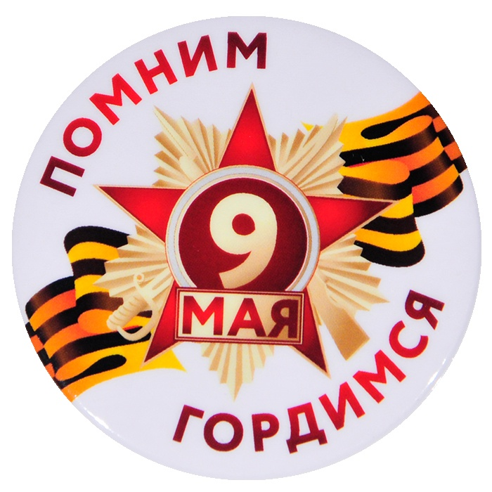 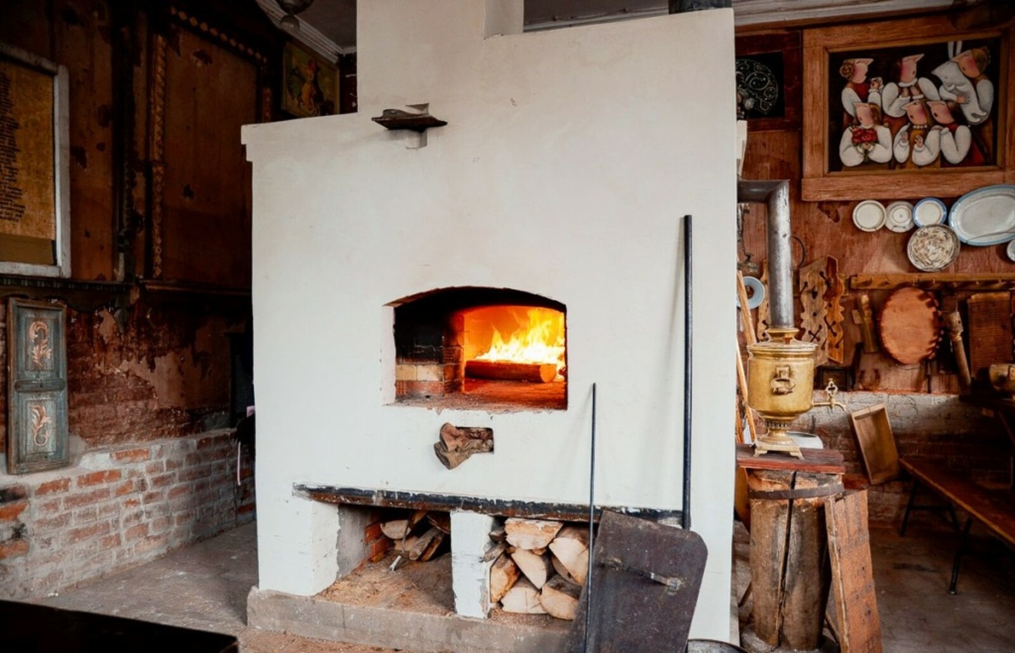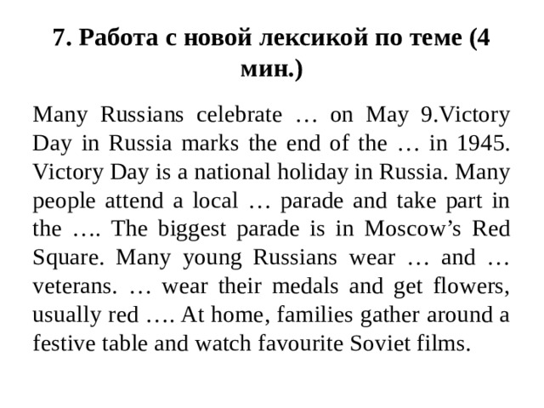

Find in the text:

1. Праздничный стол
2. Самый большой парад на Красной площади
3. Национальный праздник
4. Получают цветы
5. Надевают свои медали и ордена

Match

1. Марш Бессмертного полка a. Carnation
2. Великая отечественная война b. The Ribbons of St.George
3. Принимать участие в с. The Immortal Regiment march
4. Военный парад d. take part in
5. Марш Бессмертного полка e. The great Patriotic war